New York City Marathon 2009 – Greg McDowell
40th Running of NYC
Why NYC?
11/1/09 – On this date, I ran my second NYC Marathon and 15th overall. I had run NYC in 2005 as my 4th such endeavor. In this, my sixth year of marathon running, I completed four marathons, including 30 miles of the Boogie50. After adding several new states (now 9 + D.C.) to my list in 2007 and 2008, we decided to reduce our running-focused travels, and incorporate more running events into existing plans, when allowed. Thus, 2009 included a second marathon in Sarasota close to our second home, and a “local” NC run. OK, there was also a quick trip to Cleveland for the Rock and Roll Marathon (and visit to the RNR Hall of Fame). This trip to NY would provide an opportunity to visit May’s family in NJ. The repeat run would provide me an opportunity to overcome logistical distractions and soak up the experiences of running possibly the world’s largest gathering of marathon runners – 43,250 reported runners, vs. only 37,000 in 2005.

Preparation
As an experienced runner (note: experience does not equal speedy), I have absolutely no excuse for entering a marathon unprepared. Even in 2005, I had done 5 preparatory long runs (2x18 and 3x20) leading up to the event. But throughout 2009, and admittedly back to August 2008, I had run through nagging hamstring and calf injuries – all related to overtraining, or not backing off of slight injuries and therefore letting them become more serious. I ran Cleveland in May after seeking regular treatments from my sports chiropractor. Surviving that, it seemed entirely logical to attempt the Boogie50 four weeks later despite never having run two marathons closer than 7 weeks apart. After backing off a bit in June and July, my training progressed satisfactorily through the August heat (3x10, 12 and 17), which continued (i.e., the heat) into September (13, 18 and 10). However, following an enjoyable Brixx 5k with May, my next day, planned 20 mile run in late September aborted after 2 miles when my calf inexplicably tightened. Seems this was the same calf which caused me to walk about half the New Mexico Marathon back in August 2008, allowing me to set a personal worst time finish by about 45 minutes. It would be three weeks later, and only two weeks prior to NYC09, that I would run a 10 miler. In between, I made a few visits to my sports doctor and endured the helpful suggestions of friends and family alike who wondered aloud why I didn’t skip this particular race. Besides the scheduled airfare and other plans, the non-refundable registration fee alone was $171. And such is the lure of running a marathon, with the lottery process for NYC (and #40) in particular; one does not abruptly or willingly run, walk or limp away from the opportunity. Except for the Boogie, I have never not finished (DNF), and except for December 2006, I have never failed to reach the start line for any of the 40+ races I’ve registered. Yes, I would show up. And despite a varied preparation routine which gave much more emphasis to the elliptical machine (6 hours) and stationary bike (4 hours) than to actual running (59 miles in October), I would do my best on the given day, at the appointed time. Yes, sometimes goals may be changed; showing up is mandatory.

To Jersey
After running a mile Friday morning, we headed to EWR via CLT. My lovely, Golden (as in Gold Preferred) Spouse had secured upgrades to First Class, and a pleasant flight ensued. Transportation Director and father-in-law Jon Aston picked us up for the 30 minute drive to home base. Eating commenced soon thereafter. Steaks were soon on the grill, and the usual variety (and large quantities) of Italian fare awaited. A little vino also began to flow. Since I could not arrive well-trained, I would rely upon a new approach of being well-rested. I napped and kept my legs up. Despite a restful afternoon, I also got a very good night’s sleep. Eating re-commenced before daybreak, and then the four of us (May, her folks Jon and Vivian, and I) headed to the Javits Convention Center to pick up the required race bag.

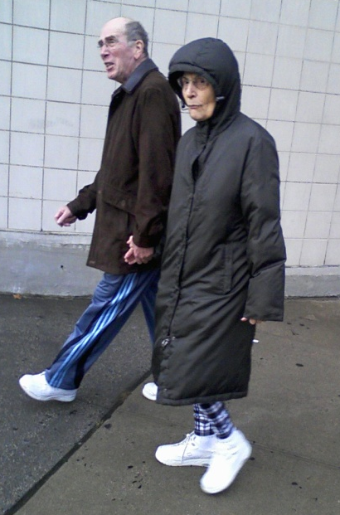

We also made a pre-race video, which will append the DVD I ordered. These big ones (NYC and Marine Corp) provide videos where you can find yourself along the course – actually running! (Hard to pass up these celebrations of Self.) May meets and greets Triathlete Sarah Reinertsen below, (of The Amazing Race) in the Convention Center. I believe Sarah was the first female, above the knee amputee, to complete the World Championship Ironman Triathlon. I recall seeing tv coverage of her first attempt, when she had to drop out after not completing the bike portion by the deadline. Sarah is not running NYC this year; she is promoting her new book, and meeting/greeting fans like May.

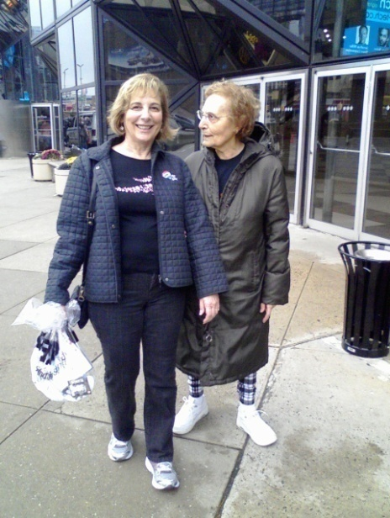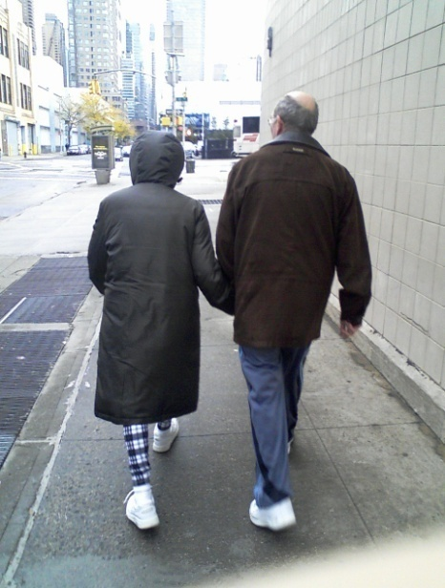

We returned to home base for more steak – beats me! – it just kept appearing on my plate, and other tasty fare. I eat in (somewhat) moderation. Later, about 4pm, I ate my final portion of angel hair pasta (thanks to the Director of Nutrition Vivian), determined to avoid overload. May and I take a walk, enjoying a warm afternoon among trick-or-treaters wandering the Hasbrouck Heights, NJ neighborhood.

Race Day
After a somewhat restful sleep, I arise just before my 4:00am alarm. The change to daylight savings provided an extra hour of sleep. I ate a banana and a bagel with peanut butter before taking a warm-up jog. It is slightly misty and cool. The weatherman is cooperating. My knee had begun feeling gimpy the night before and it continued this morning. While it’s been 2-3 years since an MRI disclosed a slight tear in my meniscus (cartilage), a weekly regimen of weight lifting keeps the pressure off the joint and the body from undergoing the knife. I had done two regimens in the preceding week, since I was engaged in a full taper routine which allowed such luxury, and varied exercised helped ease the normal jitteriness of waiting. So, there really wasn’t a good explanation for this feeling. But it would give me something else to think about while wondering whether a hamstring or calf would act up. (When I actually began running over 5 hours later, I felt the hamstring, but nothing in the knee, so again – no explanation.) My morning race day routine includes a warm shower, which followed the brief jog and light stretching. I had attached my bib (race number) to my shirt, and laid out my clothes, including the bag of extra clothes which would hopefully await my arrival in Central Park. So there really wasn’t much to do in advance of the scheduled 5:45am departure.

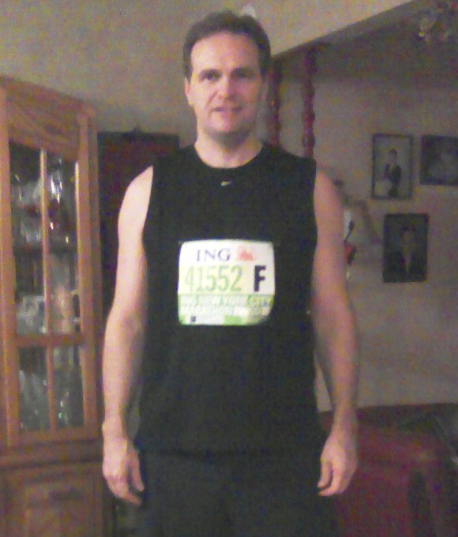

Jon would drive me to a pick-up near the Meadowlands, about 15 minutes away, as buses were on a continuous departing schedule from 5-6:30am. A couple parting pictures were taken of me (above), and of a sleepy May and me (not included). The drive to the Meadowlands took all of 15 minutes, and a 30 yard walk to a bus which was nearly full put me on a sufficiently early schedule. (First Text Message to May, 5:53am – “On bus, A OK.”) I chatted with a fellow from Nebraska who had run NYC08 and was slotted in the first wave. We discussed our training and recent injuries.

Staging at Ft. Wadsworth

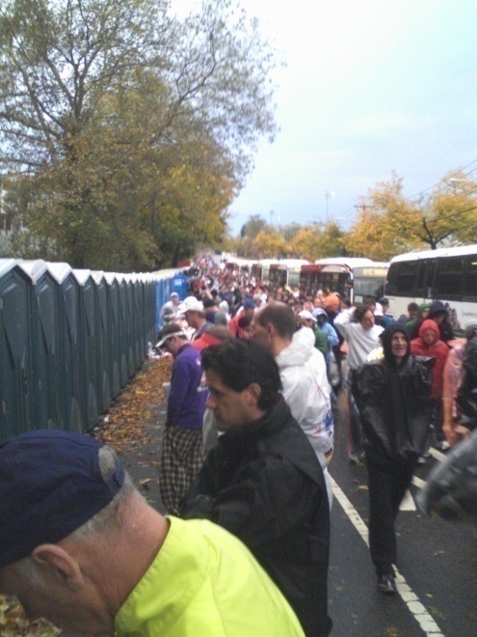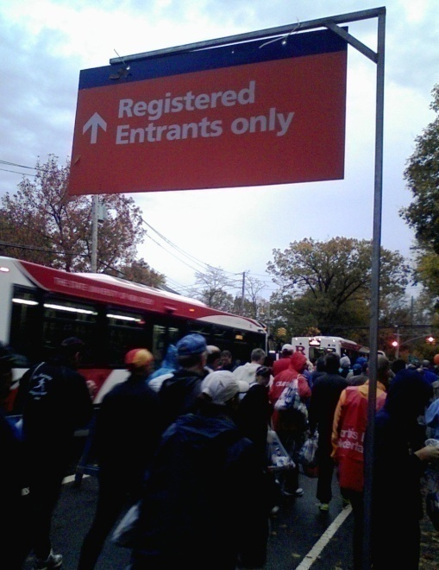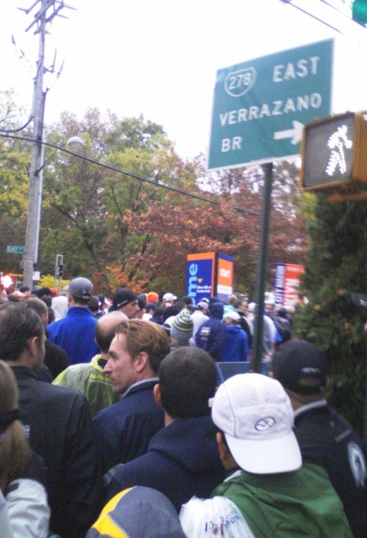

Arrival on Staten Island meant joining a long caravan of buses which unloaded hundreds upon hundreds of runners along a street, where the crowd followed a few signs and each other toward the staging area. A mass of bag-toting, bundled runners speaking several languages besides New York-eese, with a few umbrellas in the mix, squeezed past some security guards who really did check some bags, into the large staging area which would be our home for a couple more hours than I preferred. I followed signs for upwards of ½ mile to the Green bib staging area. (Text to May, 6:41am – “Arrived, Now long line 2 staging area. Sprinkling, not bad.”) My first impressions were that I had only a vague recollection of the area from four years ago, although there were about 10 times as many porta-pots as 2005, when I stood in line for 45 minutes before ever getting to a rest area, where I began making phone calls (that was my first time to carry a phone). Once I arrived in my designated area, I was surprised at the sparse crowds. There was no line to drop off my bag at the numbered UPS truck, and at least three attendees awaited my arrival to hand me food at the bagel stop. Despite the small numbers, loudspeakers were blaring in at least 4 languages on a rotational basis to instruct us regarding our assigned area, the UPS drop-off and food. Small groups of runners had formed, often by nationality and sometimes in matching garb, and most had prepared for the wait by bringing large blankets or plastic garbage bags. There were varied attempts to wear disposable, yet warm clothing, as the 3+ hour wait would include periods of mist, sprinkling and breezes. I found a spot to sit along a fence, providing something to lean on, and spread a garbage bag on the wet grass. I was near the trailer portion of a tractor-trailer, where several brave souls huddled under the structure. One fellow was barely visible in his makeshift sleeping bag. A few seemed to be comfortably asleep. Most sat and chatted. I’m not much of a talker at times like this, but I like to listen. Unfortunately, most of the conversations were in foreign languages, as something in the range of 20,000 runners come to New York from other continents. I would learn later that at least 5 countries exceeded 2,500 entrants each. (Italy sent more than 3,500.)

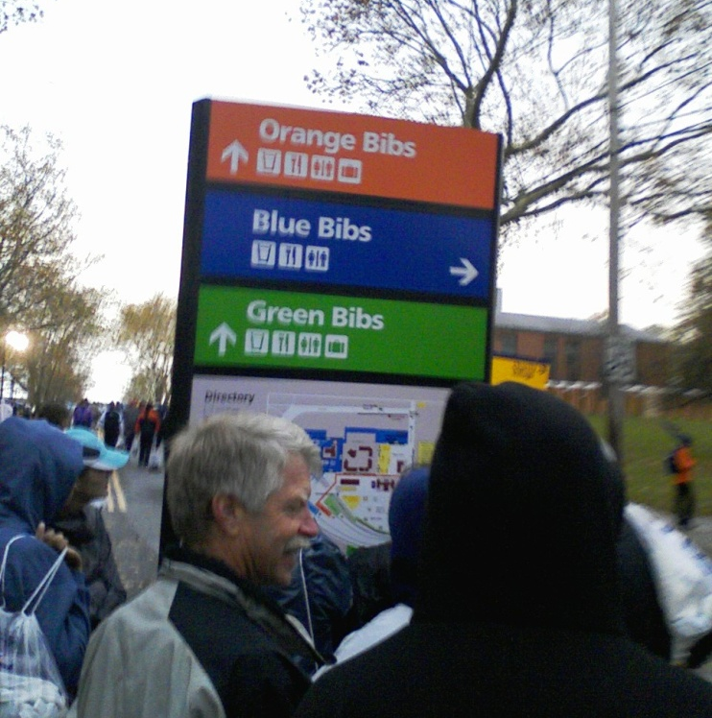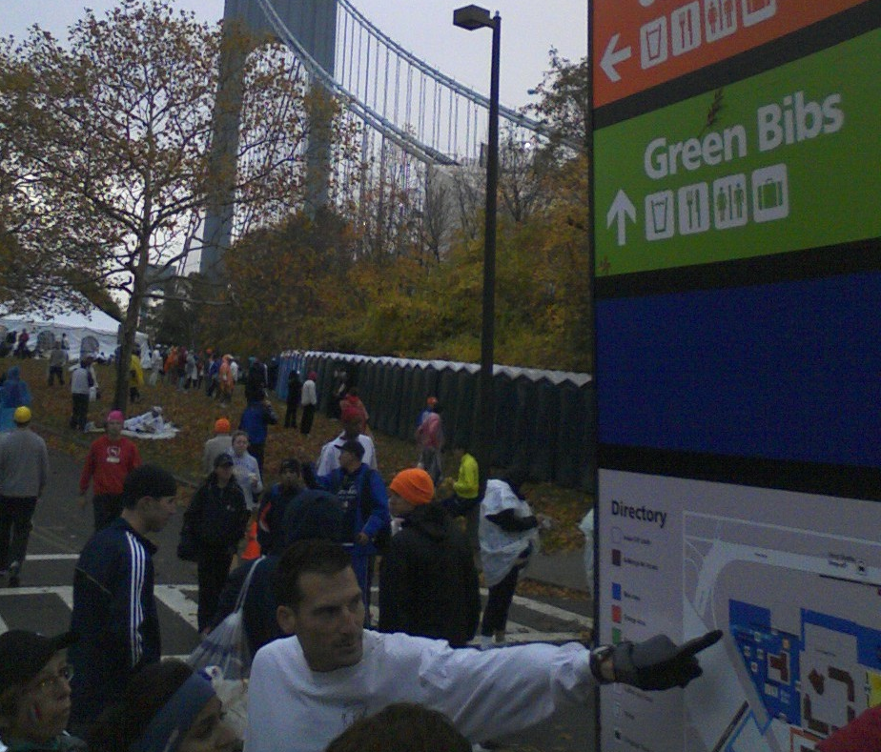

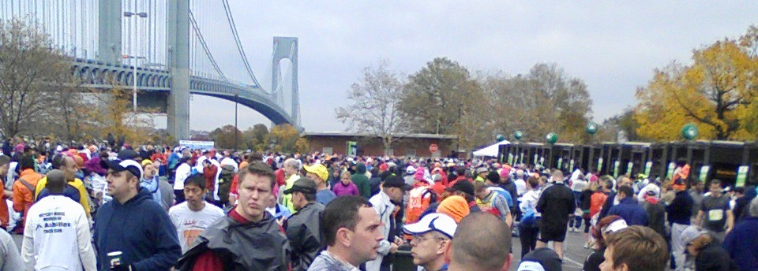

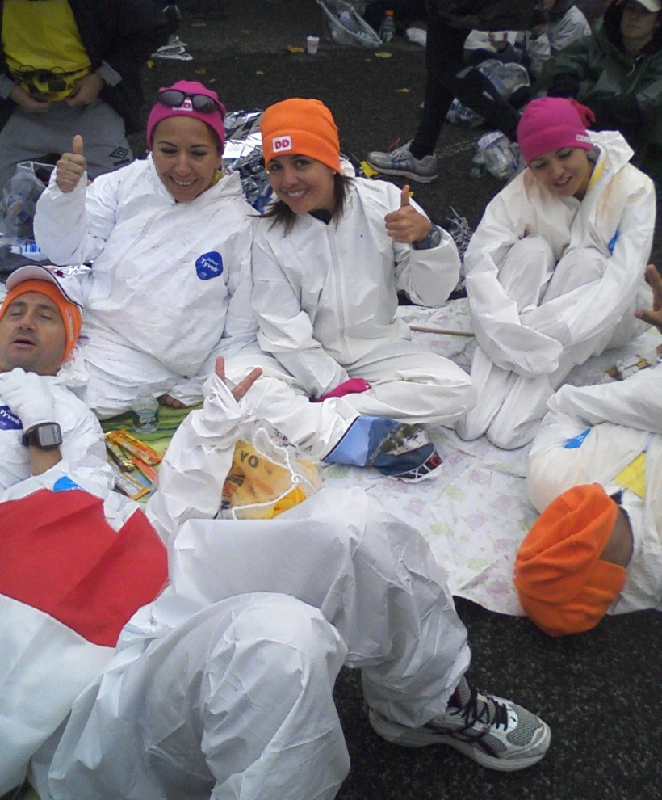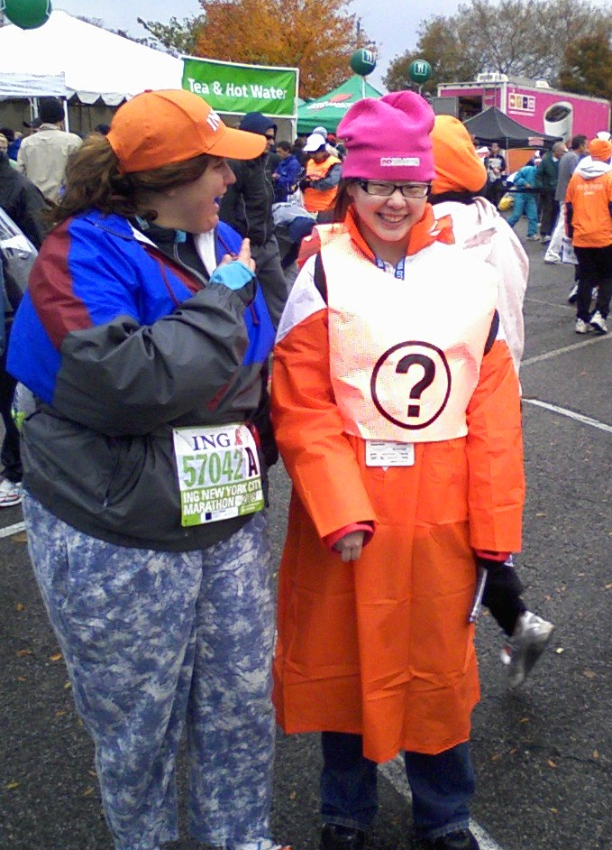

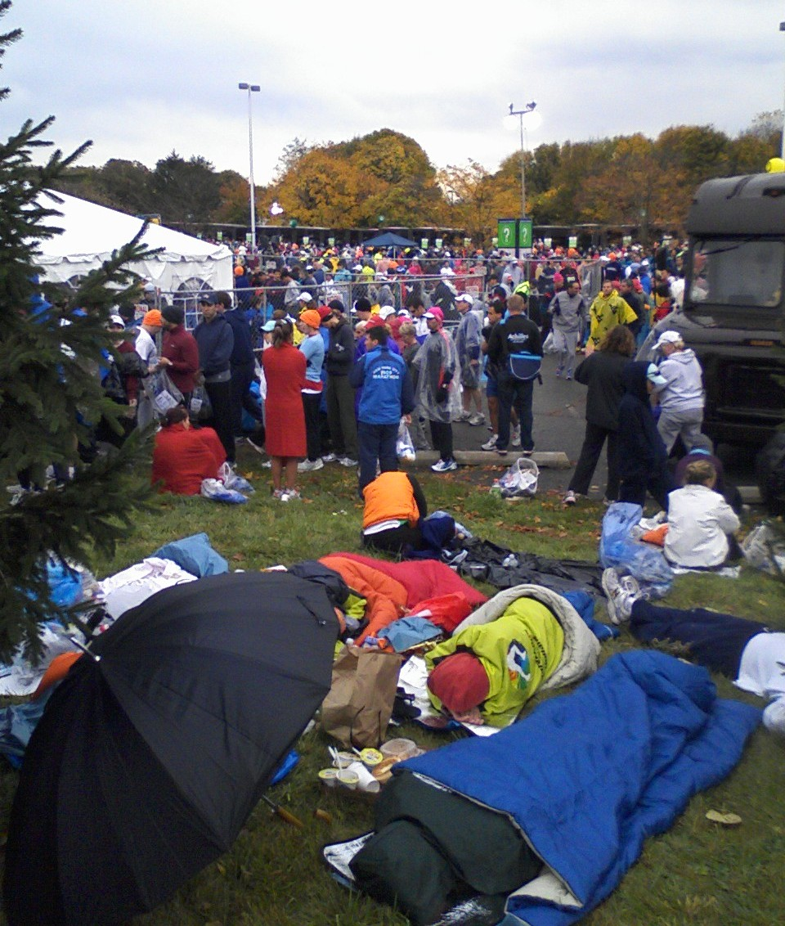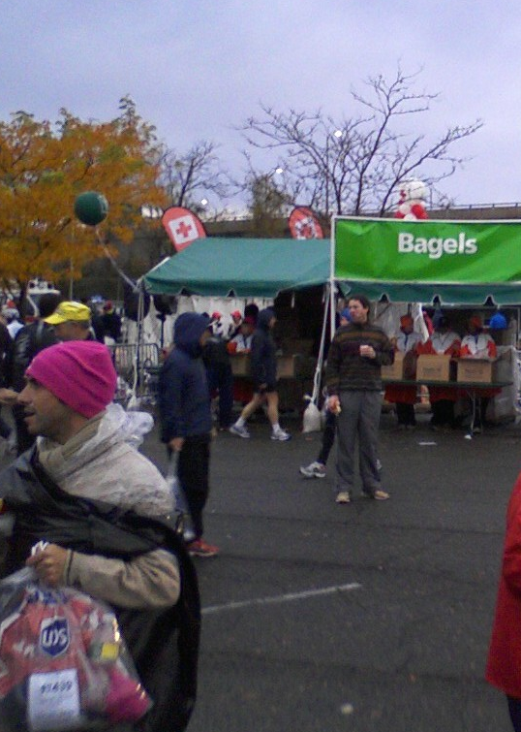

Selected Text Messages from Staten Island
- Texts to May, sister Deb, John Trunk and Ron Horton, 7:07-7:20am – “Sitting in lite rain w 3 hrs to kill. Busy village.”
- To May, 7:25 – “Id call, but no way 2 get away from loudspeakers making constant foreign announcements; Learning new languages, Im sure. Not sure how I will feel in 2 hrs. Leaning against fence. Dressed warm, @ least.”
- To Ron, 7:36 – “…Ready to start.”
- To John, 8:02 – “Bored 2 tears, annoying loudspeakers. No English spoken nearby. Ready, except 4 legs.”
- To Ron, 8:21 – “Chilly, had some rain, breezy, may start w throwaway sweats. First wave lining up.”

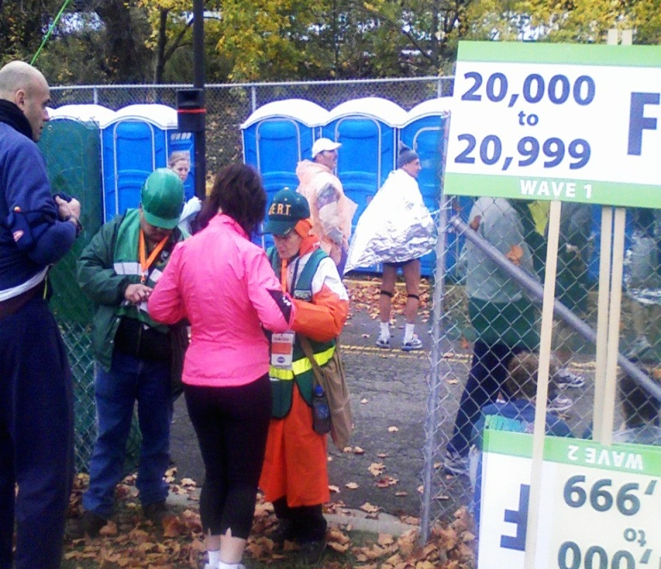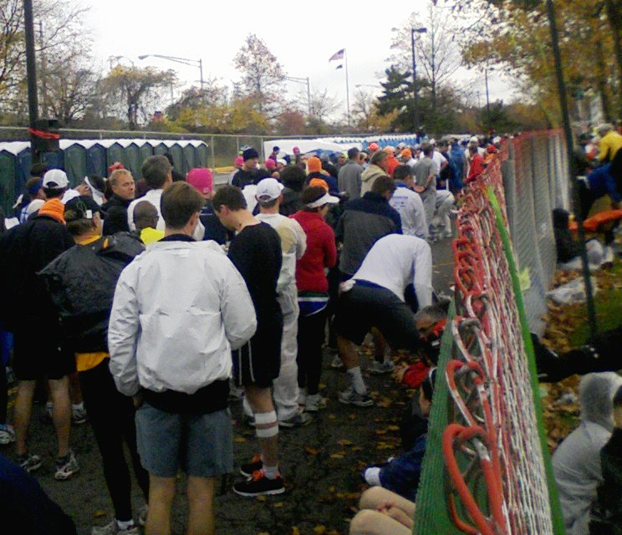

(At 8:30, I move my plastic bags and supplies from the Green staging area to just outside the corals. This is a new system, and I’m unsure how it all works, and whether there might be an opportunity to slip into the first wave – there isn’t. But the loudspeakers are out of earshot, and there is a band playing on a stage. I probably should have moved over here sooner.)
- To May, 8:44 – “Getting exciting, music. 1st wave lining up, lots of energy here. Wish u cd c.”
- To John, 9:14 – “Final hour, 1st wave is in their corals. Music, etc. I just want to enjoy a few miles. After that, ?”
- To Ron, 9:30 – “Coral system breaking down a bit. Crowding up now.”
(At 9:40, following a brief word from Mayor Bloomburg, the first wave receives its signal; the crowd which is not so distant begins to move and Frank Sinatra’s old standard plays. My group applauds and cheers, and inches forward.)
- To John, 9:43 – “All good. Wave 1 is off. Going radio silent.”
- To May, 9:50 – “10 min, im ready. Crowding up.”

Picture below captures first wave running in the distance. Note two levels of runners as they approach the double-deck Verrazano-Narrows Bridge.

The second picture below captures the second wave of runners filling the corals and adding their discarded clothing to those left behind by the wave one runners. Much is thrown or hung on the fence. I note that some of it is good quality stuff. It will be collected and distributed to charitable organizations. Ropes separate the corals A-G, but quickly break down as runners slip under and over the lightly guarded barriers.

The third picture shows the coral behind me really filling up, and the first wave runners still running in a distant crowd.
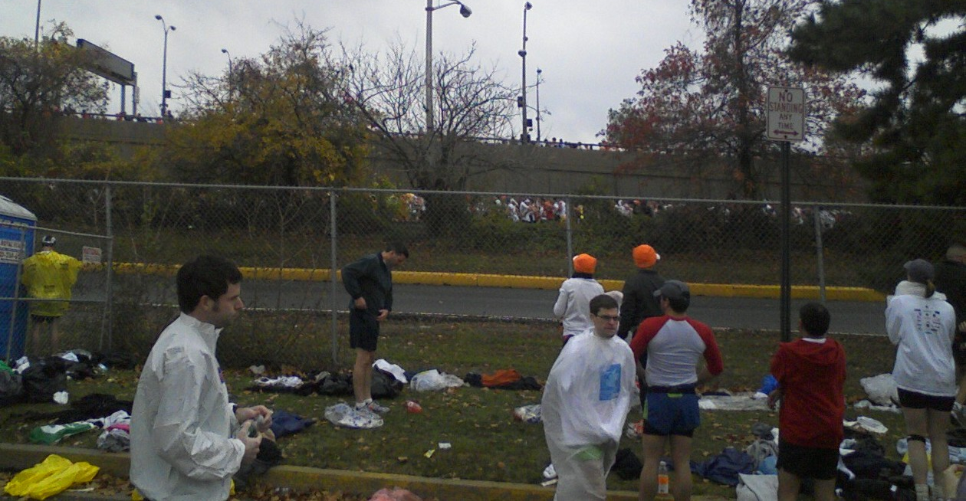

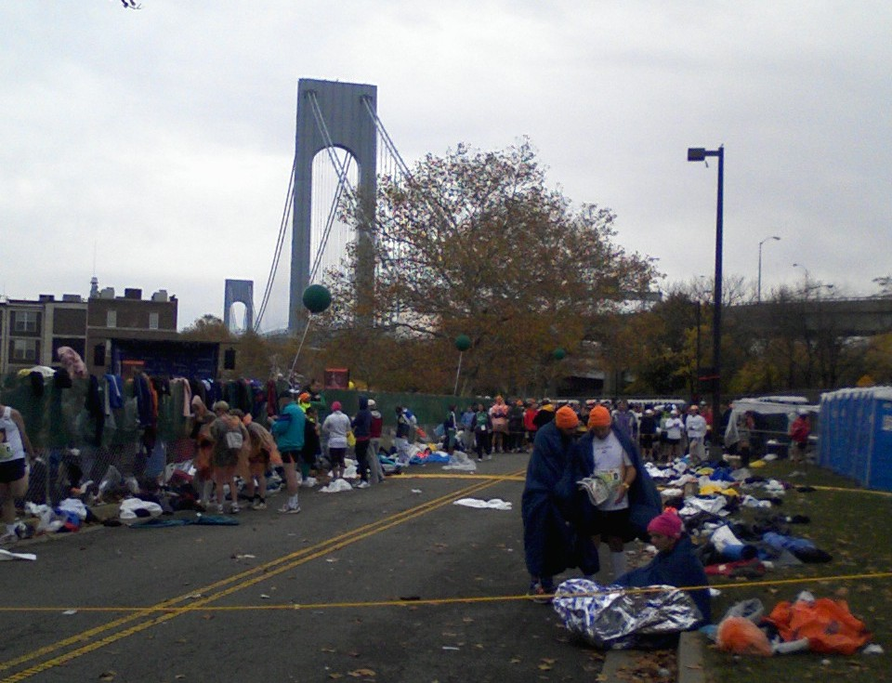

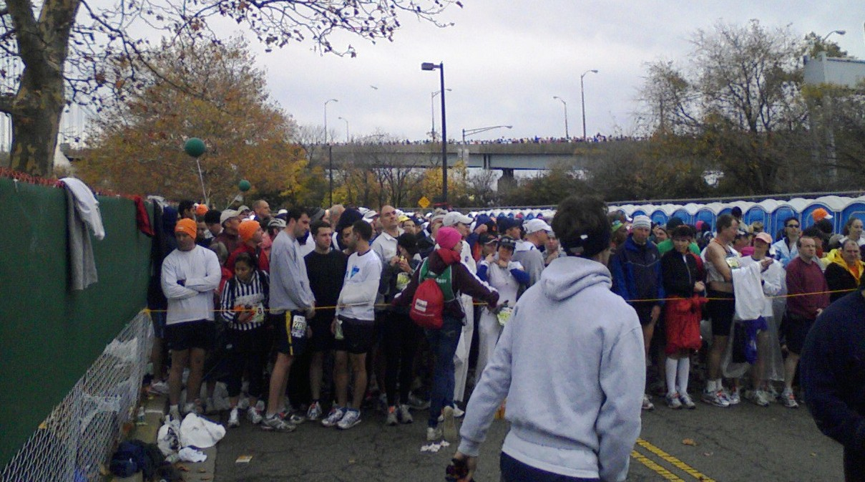

Staten Island/Verrazano-Narrows Bridge
Shortly before 10, the Green bibs in wave 2 move toward the second start. We are assigned to the lower level of the V-N, drawing the short straw, as I did in 2005. The Blue bibs and the Orange bibs move similarly to their two lanes which will take them on the upper level of the V-N Bridge. There would be a third wave starting at 10:20. I’ve kept my throwaway cotton sweats on, as I’m chilly from the inactivity and the still low 50s temperature, along with some breezes. This seems like an even better idea when I’m running midway across the bridge. A howitzer gun signals our start. There will be a minute or two walk to the actual starting line. I am in the front 20-30%, with a huge crowd behind me. Each wave is estimated to take 6 minutes to complete its start, so there should be a good size break between the waves. This presumably will decrease the bumping and elbowing through the tighter sections of our course. But of course, the size of the field continues to increase each year, so it remains to be seen.

Below, I approach the actual Green Bib START.
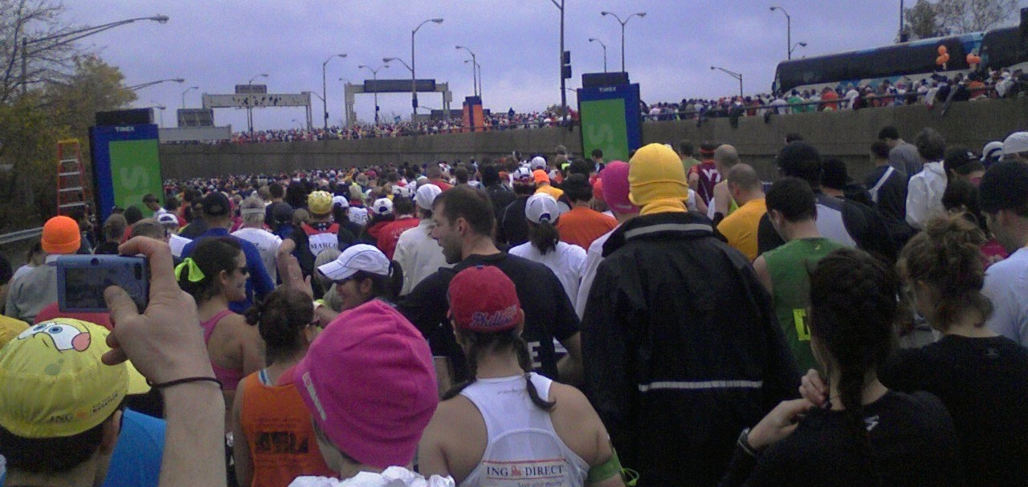
I focus on my footing. After all the planning, training (ok, not so much), and logistics, one does not want to abruptly end the marathon attempt with a trip, stubbed toe or such. The bridge has several connections and bolts you don’t want to step on. Some are spray-painted orange. The sea of runners is boisterous and there is a slight echo in the open, yet cavernous lower bridge level. I stay to the left, with a view of Manhattan unfolding. I attempt to take a picture of the boat shooting water in the air – this is somehow for our benefit, I think. Some runners stop completely on the adjoining sidewalk to take photos. That seems like a good idea, but I don’t want to be on the edge, where a slip of the hand could cause me to lose my phone altogether. I have already taken several pictures, and I will total about 60 for the day (about half are included in this document). There are so many images to process in my mind; I’ll need help to recall even a fraction. As expected, the first mile is slow, but I am unconcerned. I plan to run no faster than 10 minutes per mile and I will take periodic walk breaks to ensure my limited amount of training will carry me the entire distance. After a bunch of these things, I know that I have my usual drop-off in the second half. When well-trained, I can delay the drop until mile 15 or 18. Today, it could easily occur much earlier. Besides slow, the first mile is uphill, maybe the steepest of the day. But it is not difficult because of the crowd, the energy and being well rested. It takes nearly 11 minutes. By the crest, I am running easily, still watching my footing, but thoroughly enjoying the faster pace. My 10:49 is followed by a 9:23.
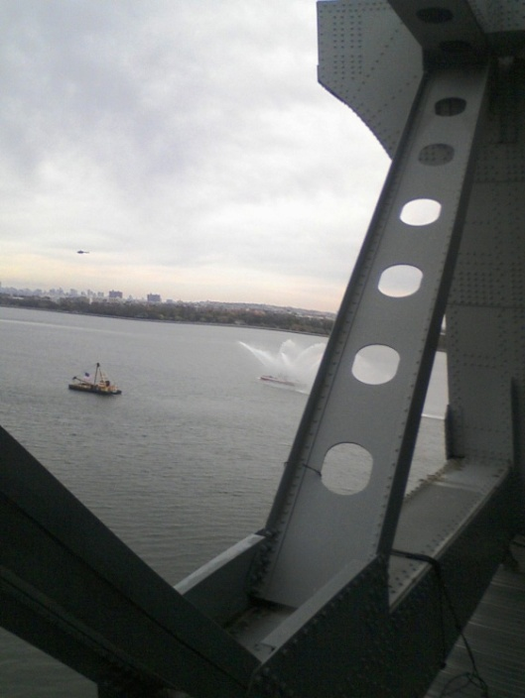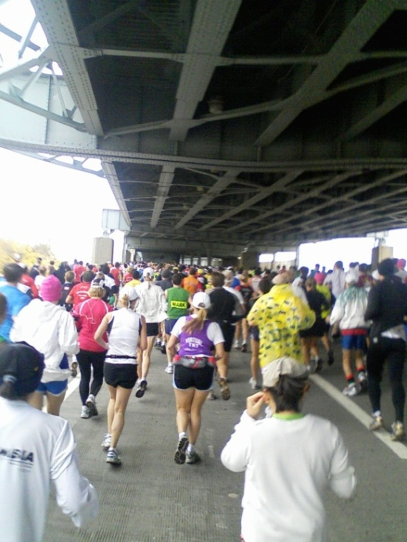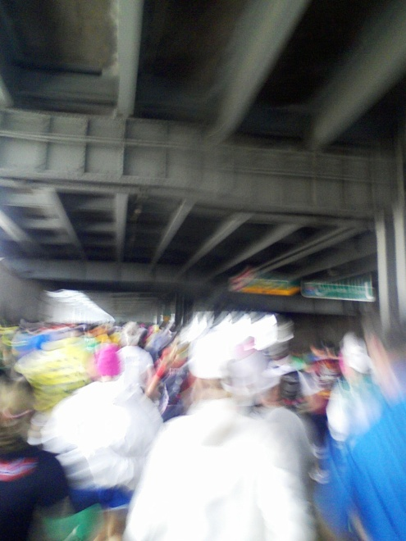
Brooklyn
I don’t see a sign, but the Staten Island portion of the run is abruptly completed and I immediately sense the lack of wind and a need to discard my sweatshirt. Shortly after, I pull over to a concrete barrier and remove my sweatpants, which requires the systematic slipping in and out of each shoe. (I often go weeks without untying or retying my shoelaces. It’s an acquired skill.) It feels great to be free of the added weight and restriction, but I am grateful that I didn’t discard them prematurely. The lost seconds don’t bother me. I calculate the accrued benefits of early rest and recovery, and smile. Our Green bib group has gone its own route and will not rejoin the Oranges and Blues for a couple miles. I have plenty of room to run; perhaps this wave thing is working. I find my pace and feel comfortable. I still feel the troublesome hamstring, but no more than I have for months. I will keep monitoring that feeling and adjust if necessary. Post-race, I see that my second and fourth miles of 9:23 and 9:25 are broken by the 10:06 which included the brief stop. Shortly after, I settle into an even 10:00 pace.
- To May, 10:33am – “Good @ 3!”
- To May, 11:02am – “6 mi, stil good!

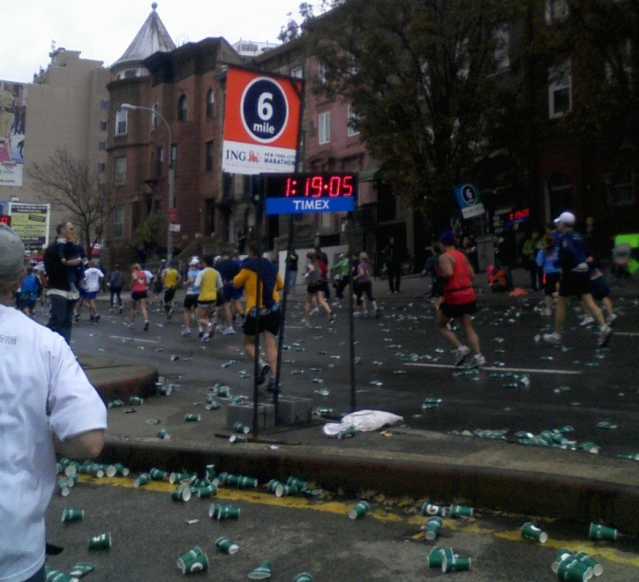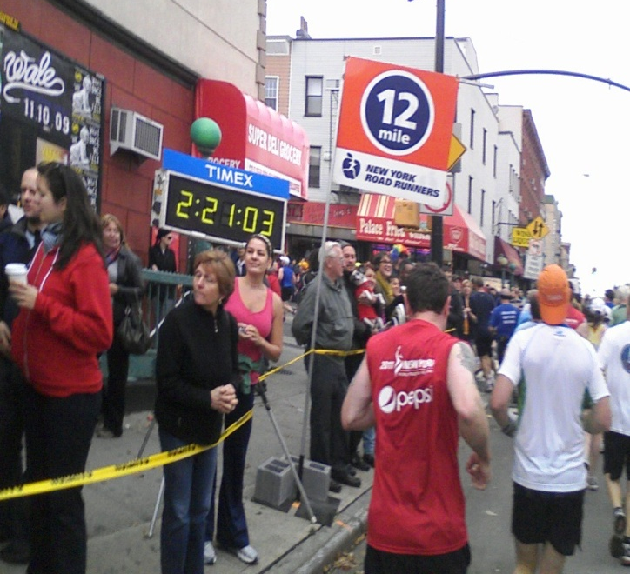

For five miles, we run up Fourth Avenue in Brooklyn. Although I usually stay safe within my own running cocoon, I feel inspired to slap hands with small children lining the street. It seems vaguely familiar, but only in the way a marathon crowd can seem. I don’t know my Boroughs well, so I’m trying to soak in images, something to remember years from now. I move to the southbound lane, as it seems to be less crowded. I encounter the banana group. As in 2005, the group hands out bananas and again, it seems like a good idea to take one. It is warm. It goes down easily; a shame to have to litter the street, but banana peels won’t be the only thing on the streets this day. I have been staying hydrated to the point of occasional discomfort. Experience tells me that this usually passes, as the sweating process relieves the bladder…usually. I have packed several GUs, having recently changed from chocolate to berry flavored. Volunteers will hand out some GU-like product around mile 18, but I start much earlier and prefer my own.

I become aware that the concrete barrier dividing the Fourth Avenue lanes is covered with grates which allow heat and noise to escape from the underground subway, which I hear rattling below on a few occasions. This world of distinct ethnicities clinging to their neighborhoods, changing noticeably almost every mile is a world away from my daily existence. I don’t know how the regularly spaced gang signs and graffiti affect these citizens’ lives. But I am very aware that I am a visitor (“V”), and perhaps only welcome on this special day. At mile 8, we turn on Lafayette Avenue and then 90 degrees back left a mile later on Bedford. I’ve heard of Bedford-Stuyvesant; maybe Chris Rock is from this area, but today, the names have little meaning; I’m just meandering along a busy city street, watching the miles accumulate. My first 5 miles took 49:39 and the second 5 took 50:37. I am more than pleased with the pace and how I’m feeling, especially since I’m throwing in some walks at water stops. I was carrying a 20oz. bottle of Gatorade G2, but I also drink some water along the way.
- To John, 11:43am – “Hit 10@ 1002 avg, 2 fast. We wil c.”
- To Ron, 11:45am – “Walking hill, 1002 pace @ 10.
Imperceptibly at first, but increasingly, I am tiring. At first I think it’s just this hill. I re-check my vitals: legs okay, hydration good, caloric intake higher than usual, hmmm, lack of preparation? Could be. Shake it off, too early to accept a breakdown. Doubt rises, memories of Albuquerque where a decent run fell apart at mile 12. One mile at a time. Wow, my feet sure hurt. Not the toes; not a blister. I picture the tendons and multiple bones which have not encountered an adequate amount of adaptation – i.e., training.
- To May, 12:02pm – “Sore @ 12.”

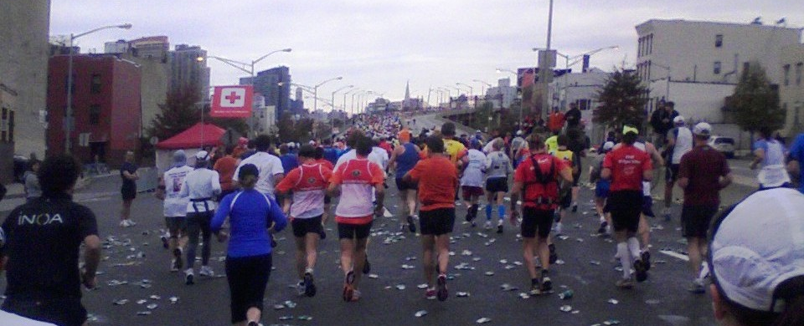

I pass the halfway point in 2:14+. This comes at the Pulaski Bridge, which separates Brooklyn from Queens. It will be a brief visit in this Burrough.

Queens/Queensboro (59th St.) Bridge
- To Ron, 12:26pm – “14, slowing.”
- To May, 12:27pm – “Slowing @ 14 as expected.”
- To Ron, 12:41 – “Walking the Q bridge, saving it up.”
- To May, 12:35 – “Walking up Q ramp. Near 16.”
Not long after that last text, I have to correct myself (“Oops! 15”), as I was not quite as far along as I wanted to hope. My brain had gone haywire. The crash is coming sooner than usual, but not in an unexpected place. This is the Queensboro Bridge, which took the air out of me in 2005. I had realized then that I wasn’t ready, and didn’t like hills. In 2005, I was shooting for 4:00, but realized after reaching the Pulaski Bridge in 2:03 that it wasn’t happening. Then the Q took what was left from my spirit and threw it into the East River. This time, I purposely walked up most of the Q. Purposely, so it could not take from me the energy I would need to run the second half of the race, which I would reach in 4-5 miles (veterans know that the final 10k is the “second half”). I was somewhat cheered to reach the 15th mile in 12:16, given all the walking I had done. This gave me a 55:43 and average 11:08 pace for the third 5-mile section. Overall, my pace was 10:24, but I wouldn’t see any more sub-11’s today.

Picture below is while walking up the Queensboro Bridge. Still quite a crowd at mile 15.
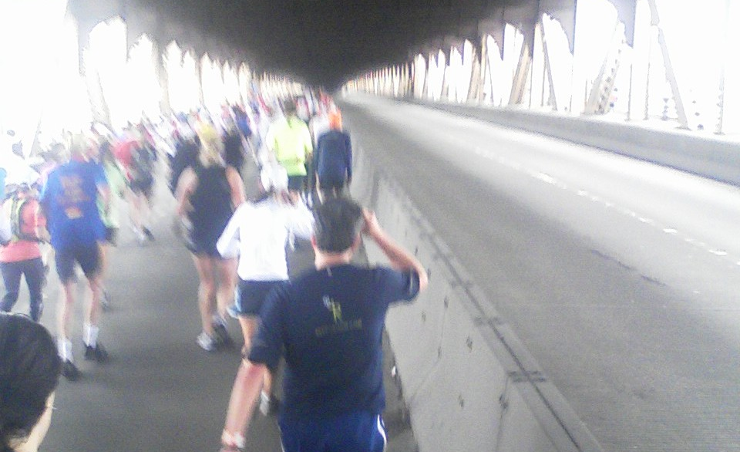

Manhattan / First Avenue
Coming off the Bridge is for many the most exciting part of the race, maybe more than the start. After a very quiet bridge run, the sound begins to build. After sparse groups in Queens, and no spectators on the mile long (or more) Q, the anticipation along with the downhill which continues off the bridge for at least a mile on First Avenue can quicken the pace of even the dead. I ponder whether my body will respond. But I don’t ponder long. I spot a row of Porto-J’s and quickly divert. The roar of the crowd is noticeable and I think how long it’s been seen I’d felt such affirmation. (I calculate the answer – 1958.)

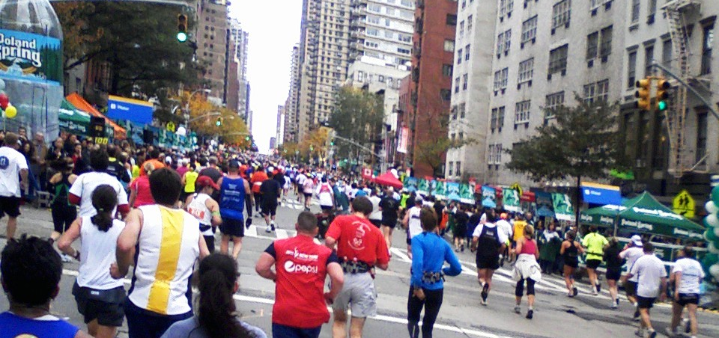

May and I begin texting our locations and figuring out how long till we meet. Either my pace quickens or I stop taking walk breaks on the long downhill. Compared to the 6-8 deep crowds of 2005, when May and I met at 66th Street, the “only” 4 deep crowds seem more sedate. Perhaps this post-Halloween timing had thinned the revelers. The rendezvous point is 82nd street, and I easily find May, her sister Laura and niece Victoria. I snap their picture as they prepare to snap mine. I hand my phone to Victoria so she can capture May and me.

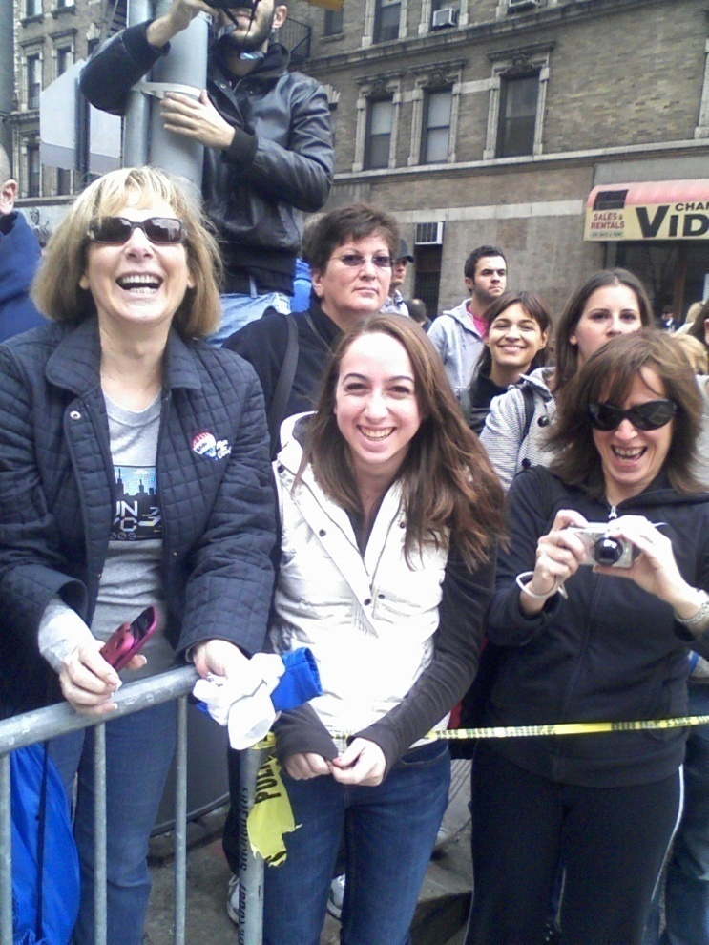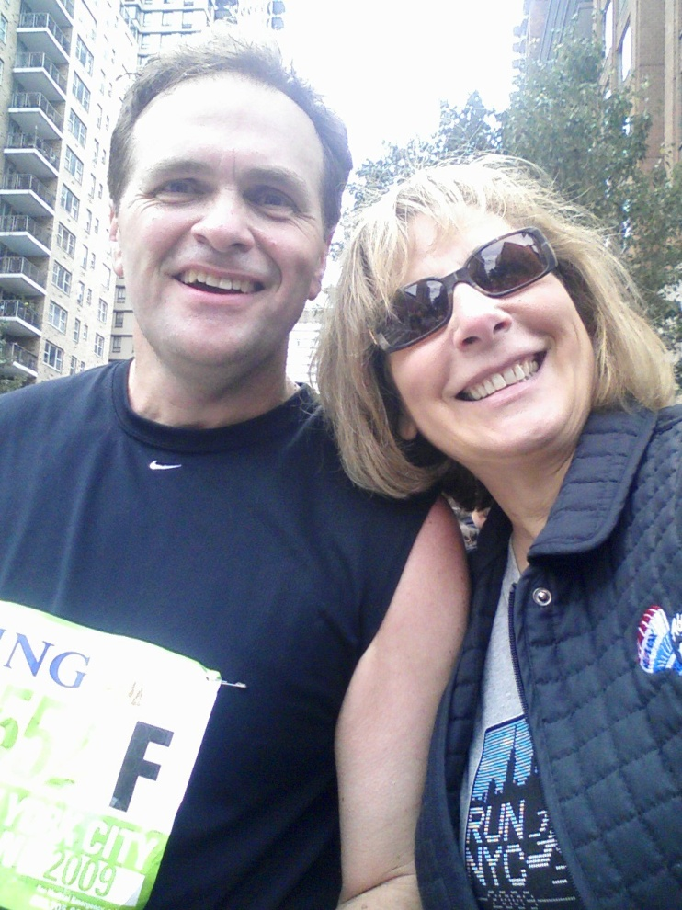

After a too-brief visit, I abandon my hat and take my sunglasses from May, and I’m on my way, somewhat energized. I will run 11:09 and 11:12 for 18 and 19, the fastest two from the Q to the Finish. By 19, I’m overly aware of my feet and every joint between them and my hips. The excitement of Manhattan, and the fun of meeting up with family is past, and mile 20 saps much of my remaining energy, taking 12:41 and causing my 5 mile split to average 11:45. The overall average is 10:45, but that number is meaningless. I had actually planned to take it easy at 19 and 20, and see if I could surge through the final 10k. I’ve had that plan before. Still hasn’t worked.
- To May, 1:31pm – “Walking n2 Bronx, I think.”

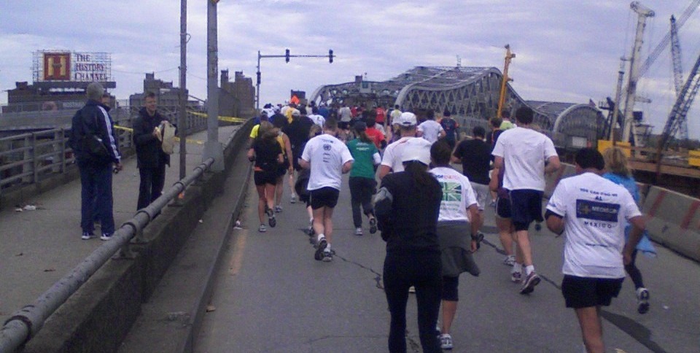

Bronx
It will be a brief visit to the Bronx; we spend even less time there than Staten Island, if you give the V-N Bridge to that first Borough. I am aware that Yankee Stadium resides here. I’ve been told that you can catch a glimpse of it if you try. I don’t. (I’ve been to the previous one, in 2000 with my sister Debby. This new one will house the 27th World Series’ victors in just a few days.)
- To May, 1:36pm – “20 done, now pain.”
- To May, 1:42pm – “Under 5 (hrs, projected), but not much. 3pm” (projected finish)
- To John, 1:52pm – “21, Pain is good.”

Manhattan / Fifth Avenue and Central Park
The fifth and final bridge, takes us back to Manhattan and Fifth Avenue. The excitement begins to build at this point as crowds of spectators begin to increase slightly. If I were running faster, I would try to hold back. But at this point, I’m just trying to run. After a flat mile of 11:46, the slight uphill makes me add some walking and my pace slows. While I’ve abandoned thoughts of 4:00 (a few weeks ago), and 4:30 (a few days ago), the early miles had me thinking a 4:40 or 4:45 would be achievable. My stated goal is 4:45 (with fallbacks of 5:00 and living to write about it), but that begins to slip away (5:00, I have confidence I will live to tell).

And…I don’t care. Because I’m alive; and I’ve avoided being reduced to total walking or limping. And I’ve soaked in another layer of marathon memories, and on top of that, a second layer of NYC – the largest one, etc., etc….But…it hurts.

Before mile 23, we enter C.P. itself. I know from the previous run that this is a big place, and there’s a lot more to go. (And from the week before Christmas when my son Andy and I were walking, no, trudging, through snow and cold to get to the Natural History Museum – this place goes on forever.) So I’m still running a bit, mostly a 12:20 pace, which counts as running because, it’s…well, it just is. And I’m oblivious to my activity. The crowd grows. The runners sense that they can complete this task. We move from Fifth Avenue into an inner road right before mile 24.
- To May, 2:25pm – “24 wow.” (I am caught up in the spectacle)
- To May, 2:34 – 1.5 to go

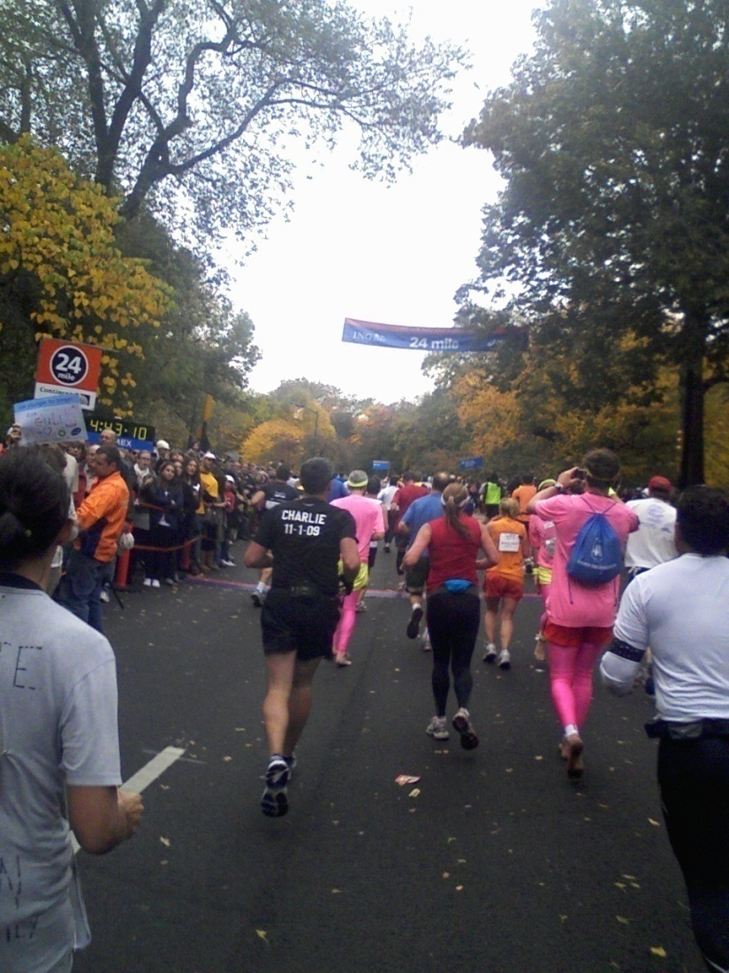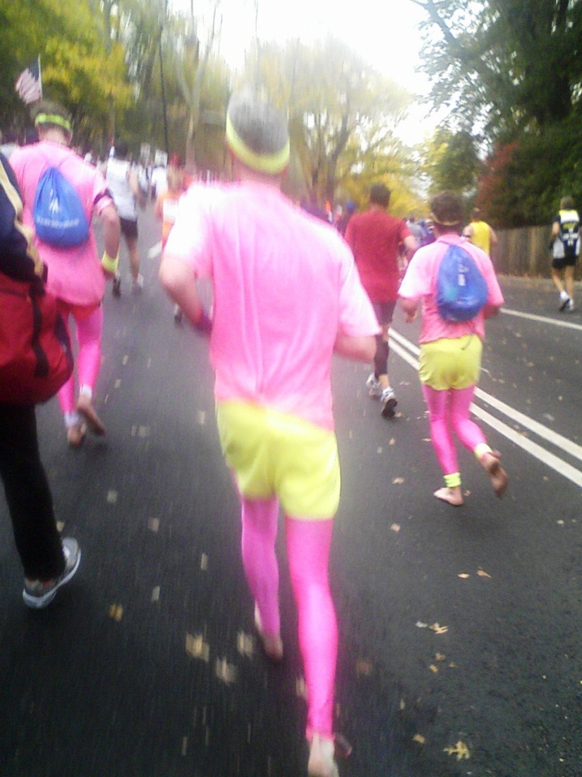

To the Finish
Now it’s a party. Runners are jumping around and yelling. I notice the three guys in pink tights – and barefoot. Everyone yells; the crowd cheers. I note that it’s not quite as crowded as my previous NYC – perhaps due to the wave approach. Perhaps because I’m 20 minutes further back. I want it to last longer, and I want it to be over. The finish line approaches. I pick my chute. I remember to not look down at my watch. As I cross over the finish line, I smile…and then choke up. I look for my medal. 30 seconds after crossing the line (4:40:52 official finish time – although the clock says 5:10, because my wave started 20 minutes after the clock), I am exhausted – and instantaneously thrown into…:

Post-race Central Park CHAOS
Where is the order? Where is the wave-effect? Why are we not moving? Why am I feeling claustrophobic? Where is water? I get water; I drink; my stomach feels queasy. We walk, then shuffle, lost in a sea of humanity.
- To May, 2:53pm – “Done!”
- To May, 2:57 – “Happy.”
- To May, 3:01 – “Walking n crowd”
- To May, 3:12 – “DK” (in response to “where are you?”)
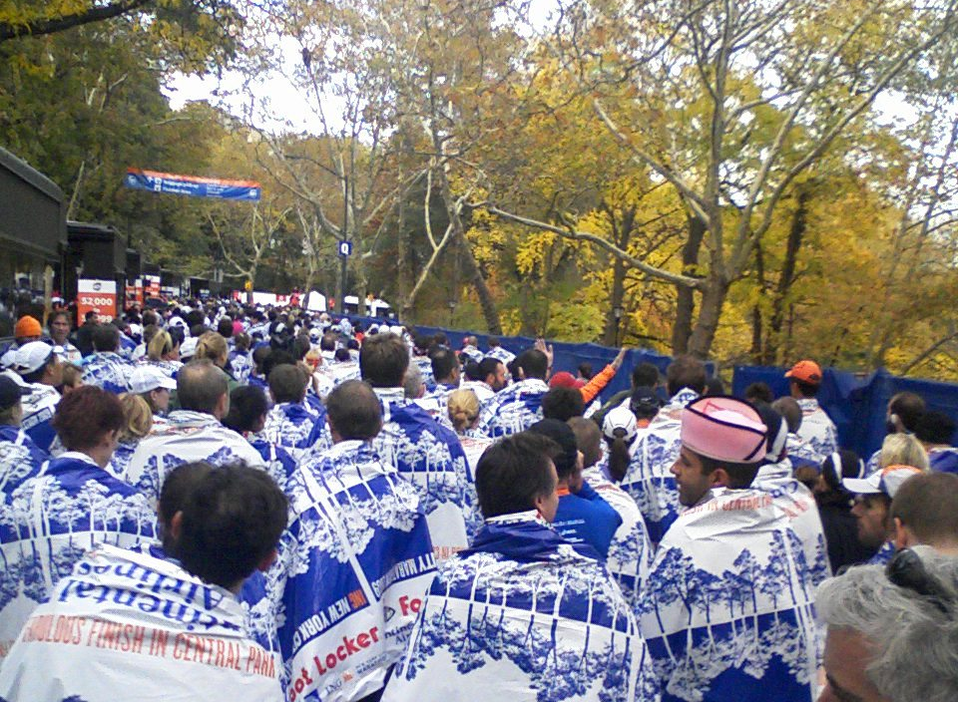

The crowd is bumping into each other; we can only shuffle; minutes pass; many minutes. I look for someplace to lean. We yield to calls of “MEDIC!” once, twice, a third time. I wonder if I should see one. It’s blurry here. I picture John Trunk falling limp at the D.C. metro stop following the Marine Corp Marathon in 2004. I walk towards a medic and announce that I need to sit. The medic barely acknowledges my presence, as two others are lying down. The crowd is not pleased that some of their walking space has been usurped. After 2-3 minutes, I struggle to my feet and begin the rest of my journey.
- To May, 3:28pm – “Hv bag, still in C.P., coming as fast as I cn shuffle.
At 3:40, I emerge from Central Park and begin looking for May…in another sea of humanity. A full 40 minutes have elapsed since my moment of pure joy. I just want it to end.

Finish line and other photos are available via this link to Brightroom Photography:

http://www.brightroom.com/go.asp?62454507

Recovery
Finally, May and I (and family) find each other in a crowd emerging from Central Park. Via phone: “do you see the purple dolphin?” Amazingly, we are each within 10 yards of this floating balloon. Time for a picture, before a relatively short walk to the car, and return to NJ. Fortunately, the claustrophobic feelings of Central Park pass, and I have supportive family to make sure I can get where I need to go. And they listen to my tale:

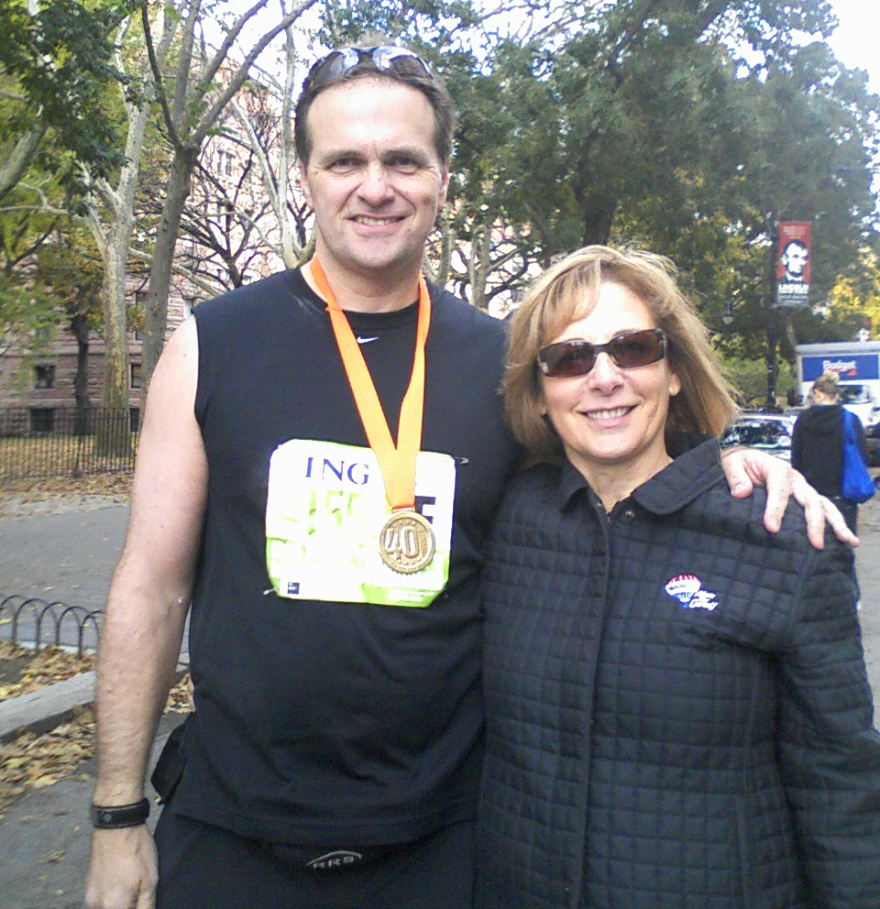

The Numbers

This is Marathon #15, if you include the 30 miles (of 50) I ran in the June Boogie50, and I do. 4:50:52 – about as good as I could expect, given the reduced training necessitated by the nagging injuries.

Post-Script

Least prepared; one of my slowest; but most enjoyable. I knew what to expect and took the opportunity to soak it in. Family support was encouraging, and I continue to be fortunate to experience a few of these things we call marathons. And NYC is one of the special ones. Not sure how long I’ll continue doing this. After the first NYC, I wasn’t sure I’d get a chance to return. After a second, it seems less likely there will be a third. Time will tell...as will I.

glm

